📊 Team Meeting & Coordination Log

Data-Driven Targeted Advertising Project

📌 Purpose
This document records team discussions, planning sessions, and coordination activities carried out during the development of the project.
It serves as proof of collaboration and contribution across different modules including backend, dashboard, and data analysis.

👥 Team Members
Krishnan S.
Rachit Anand
Abishek
A-Gowshik
VIJAYARAGUNATHAN R

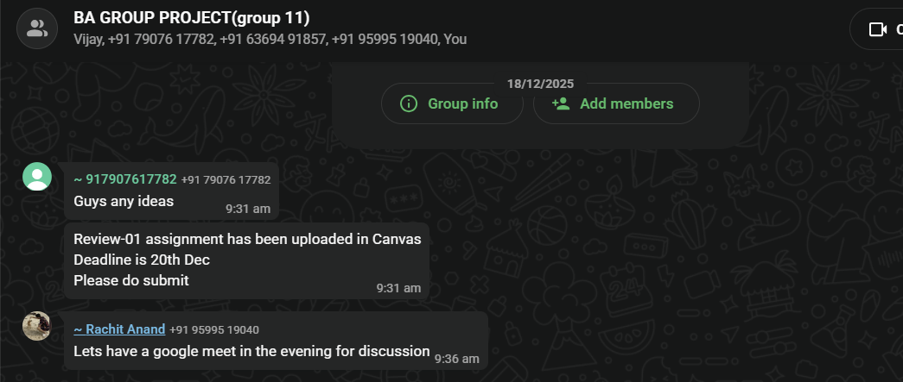
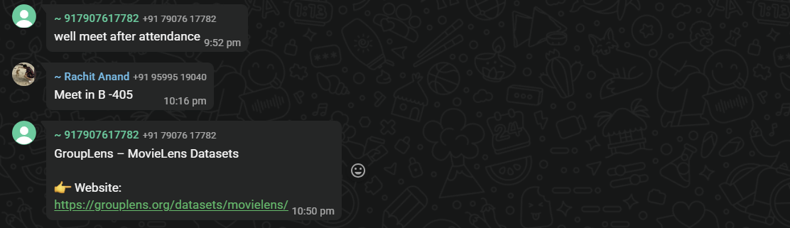

📅 19/12/25 – Project Initiation

📝 Discussion Points
Initial team formation and project brainstorming
Discussed multiple project ideas related to analytics and user behavior
Finalized focus on advertisement fatigue in mobile applications
Discussed feasibility and availability of data sources

📌 Work Done
Defined project objective and scope
Identified need for survey + secondary data
Created initial project outline

19/12/25

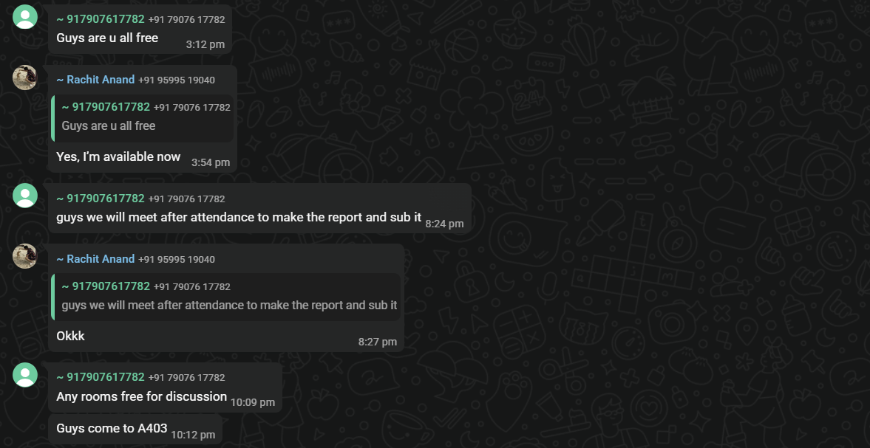

20/12/25

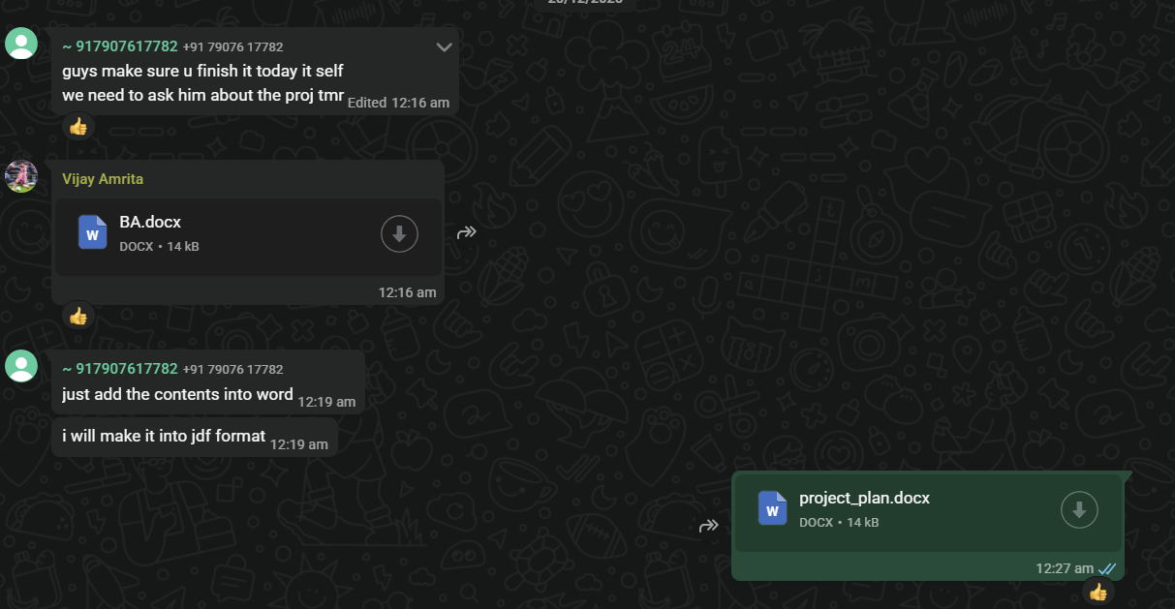

📅 20/12/25 – Survey Planning

📝 Discussion Points
Designed survey structure using Google Forms
Discussed key variables:
Ad frequency
User frustration
App usage behavior
Decided on question types (Likert scale, MCQs)

📌 Work Done
Drafted survey questions
Assigned responsibility for data collection
Finalized survey flow

24/12/25

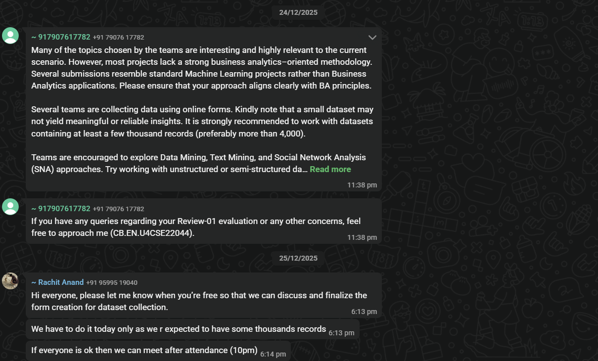

24/12/25 – Data Collection Start

📝 Discussion Points
Discussed response targets and demographics
Reviewed early responses for consistency

📌 Work Done
Started collecting responses
Monitored incoming data
Made minor fixes to survey

26/12/25


D

26/12/25 – Secondary Dataset Collection (App Reviews)

📝 Discussion Points
Selection of secondary dataset source (Google Play Store reviews)
Discussion on tools for data collection (google-play-scraper)
Planning the data pipeline for review extraction and processing

📌 Work Done
Finalized approach for collecting app reviews across categories
Identified key fields to extract:
App name
Category
Rating
Review text
Country/region
Set up initial scraping scripts for data collection
Structured raw dataset for further preprocessing

5/2/26
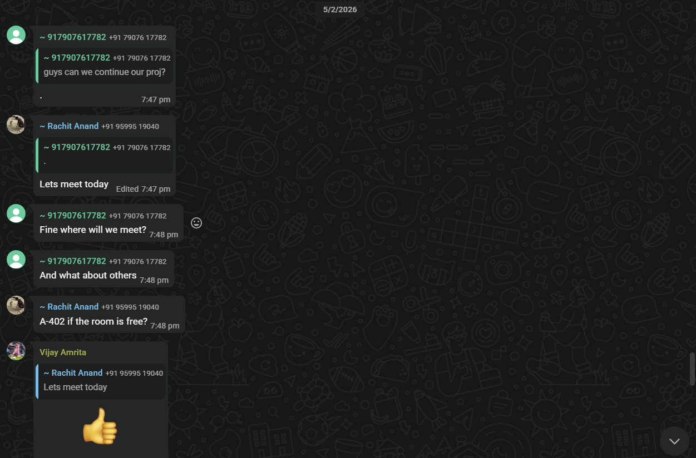

S

05/02/26 – Data Preprocessing (Survey Dataset)

📝 Discussion Points
Cleaning raw survey dataset collected from Google Forms
Handling missing values and duplicate entries
Standardizing column names and formats

📌 Work Done
Removed timestamp column and irrelevant fields
Converted categorical responses into structured format
Imputed missing values using mode
Final cleaned dataset prepared for analysis

6/2/26

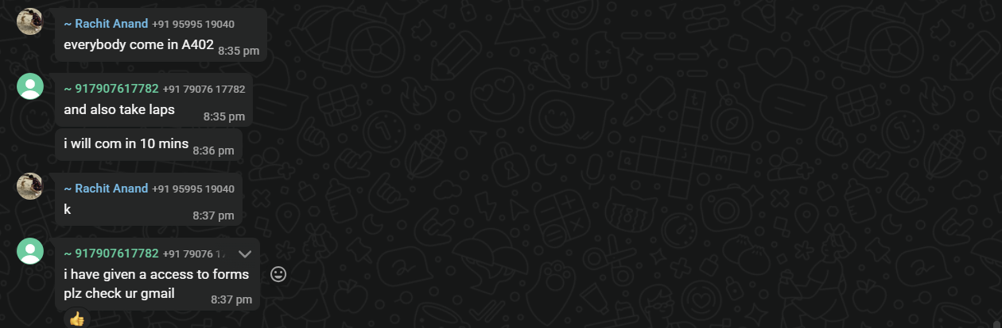

06/02/26 – Review Data Cleaning (NLP Preprocessing)

📝 Discussion Points
Cleaning Google Play Store review dataset
Removing noise such as URLs, punctuation, and stopwords

Preparing text for sentiment analysis

📌 Work Done
Applied lowercase transformation and text normalization
Removed special characters and stopwords
Filtered meaningful tokens
Generated cleaned dataset (reviews_cleaned.csv)

7/2/26

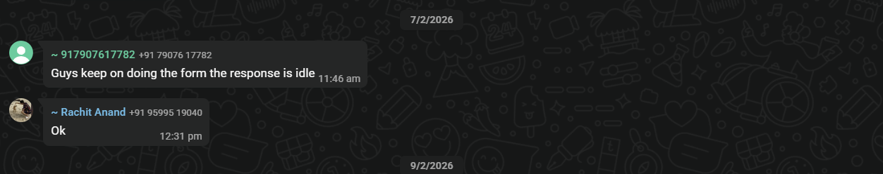
W

07/02/26 – Sentiment Analysis & Keyword Detection

📝 Discussion Points
Identifying advertisement-related keywords in reviews
Applying sentiment analysis to classify user opinions

📌 Work Done
Created keyword list (ads, pop-ups, video ads, etc.)
Implemented keyword detection (binary flag for ad mentions)
Applied TextBlob for sentiment classification
Categorized reviews into positive, neutral, and negative

27/2/26

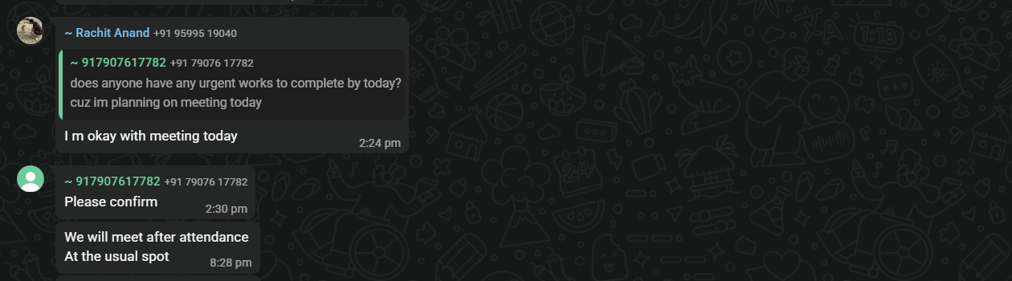
66

27/02/26 – Exploratory Data Analysis (EDA)

📝 Discussion Points
Visualizing patterns in both survey and review datasets
Understanding relationship between ads and user frustration
Category-wise and region-wise analysis

📌 Work Done
Generated multiple visualizations:
Sentiment distribution
Ad complaints by category
Rating vs ad mentions
Analyzed user behavior trends (uninstall, frustration)
Identified key patterns for further modeling

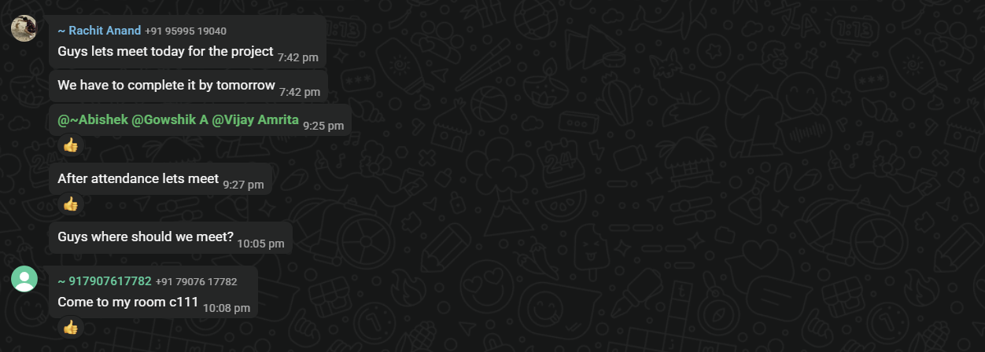
6/3/26

06/03/26 – Machine Learning (Ad Fatigue Prediction)

📝 Discussion Points
Selecting models for predicting Ad Fatigue Index (AFI)
Evaluating model performance using metrics

📌 Work Done
Prepared dataset (encoding + feature selection)
Applied:
Linear Regression
Decision Tree
Random Forest
Evaluated using MAE, RMSE, R²
Identified Random Forest as best model

12/3/26
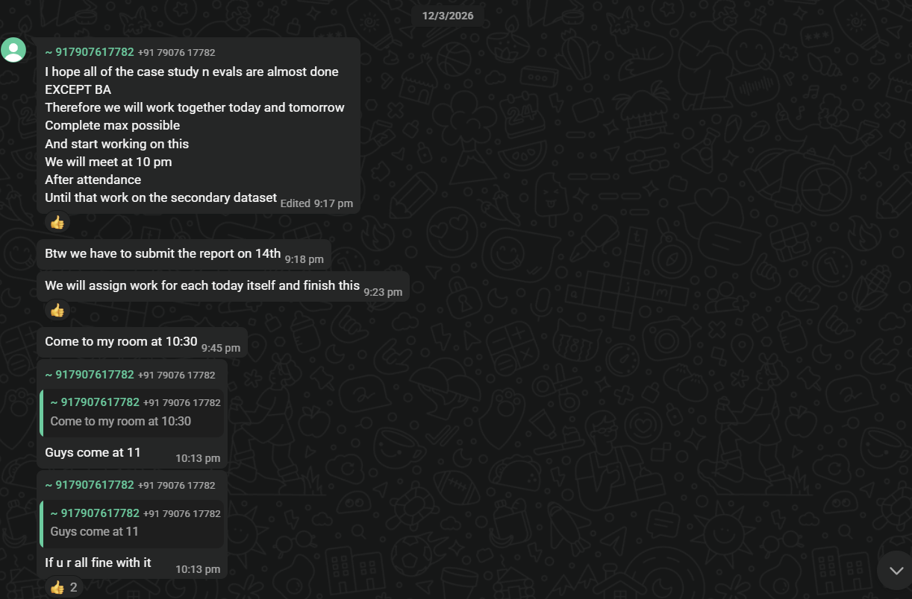

12/03/26 – Clustering, Forecasting & Dashboard

📝 Discussion Points
User segmentation using clustering
Forecasting ad complaint trends
Building dashboard for visualization

📌 Work Done

🔹 Clustering
Applied K-Means clustering (k=3 using Elbow Method)
Reduced dimensions using PCA
Identified 3 user segments:
High Tolerance
Moderate Fatigue
High Fatigue

🔹 Time-Series Forecasting
Aggregated daily ad mentions
Applied Prophet model
Predicted future complaint trends

🔹 Dashboard
Built interactive dashboard using React + Vite
Integrated datasets for visualization
Created pages for insights, demographics, and behavior

